Nurul Taufik Kurrahman

**Task 3**

1. Ingest data from local file json to Postgresql with Airbyte.
2. 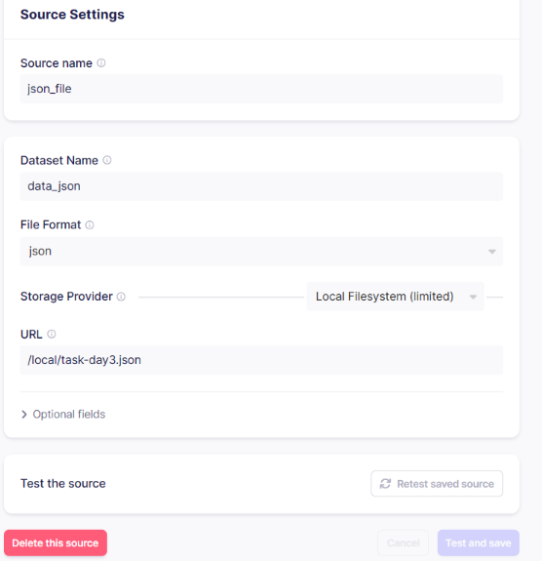Screenshot jika sudah berhasil connect ke source local file
3. 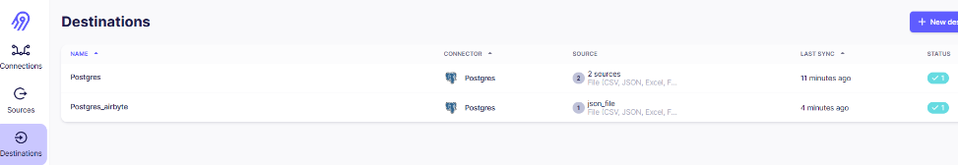Screenshot jika sudah berhasil connect ke destination postgres db
4. 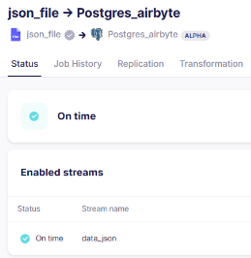Screenshot Jika sudah berhasil berhasil membuat connection dari local file / url file task-day3.json ke postgres
5. Count the number of rows ingested.

